Submit Final Grades from D2L

A simple and effective way to submit your Final Grades without having to go into Faculty Self-Serve and entering your grades. That service is still available and there are no plans to remove that option if you prefer to submit grades in that format.

- First, make sure every cell in the gradebook is filled. Even if the student has not completed the activity, that box should have a 0 in the box. The denominator SHOULD ALL be the same for every student otherwise it will be a false calculation and grade submission.
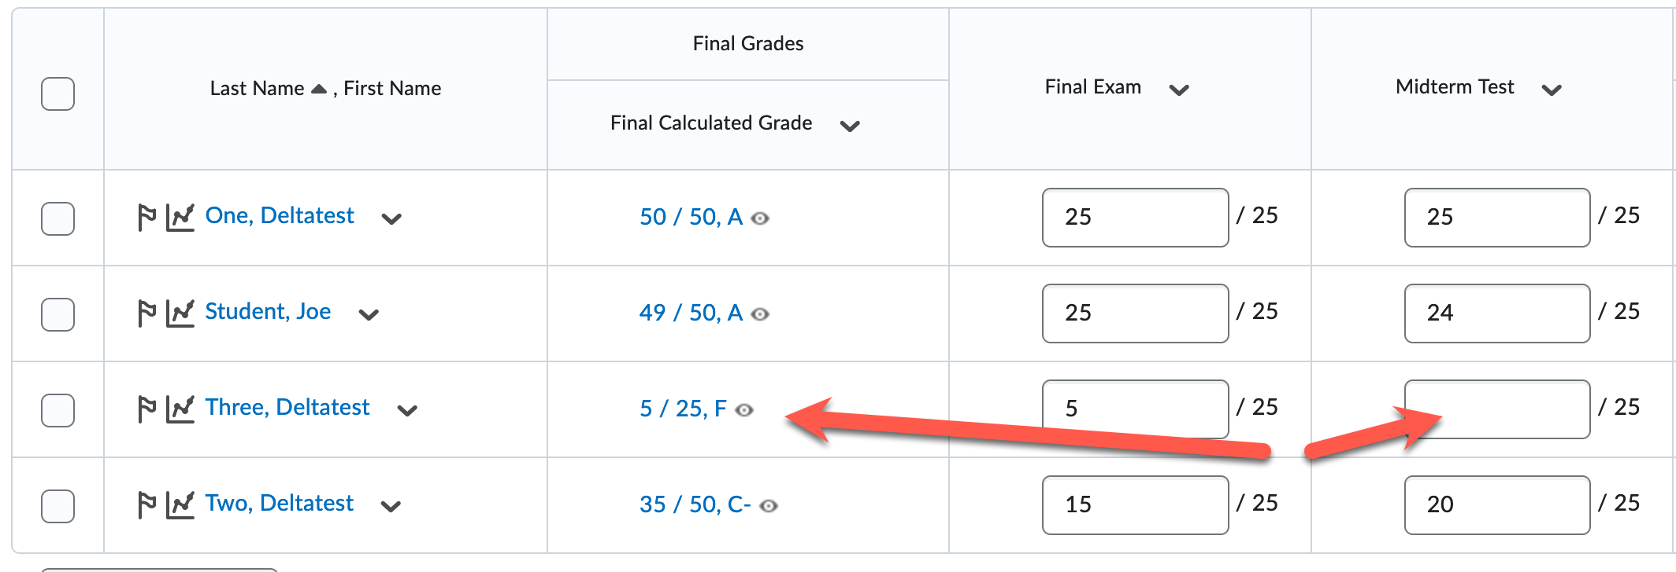
- Verify that you have grades released in D2L. If a letter grade is not available, D2L will render an error. If you are using percentages for grades instead of grade letters, you must submit grades with an override grade letter or submit through Faculty Self-Service. Releasing Grades is done differently depending on if you are using Calculated Final Grade or Adjusted Final Grade. You can follow the instructions on the employee intranet for more information: https://intranet.example.edu/online-learning/d2l-tutorials/grades.html
- To submit grades, click Grades in the navigation bar then click “Submit Grades” gray button.
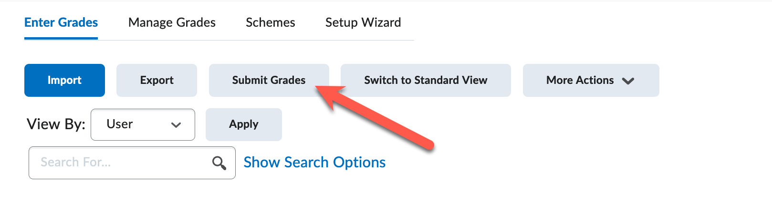
- This next step will be different if you are submitting grades for a single course or a merged course.
  - Single Course
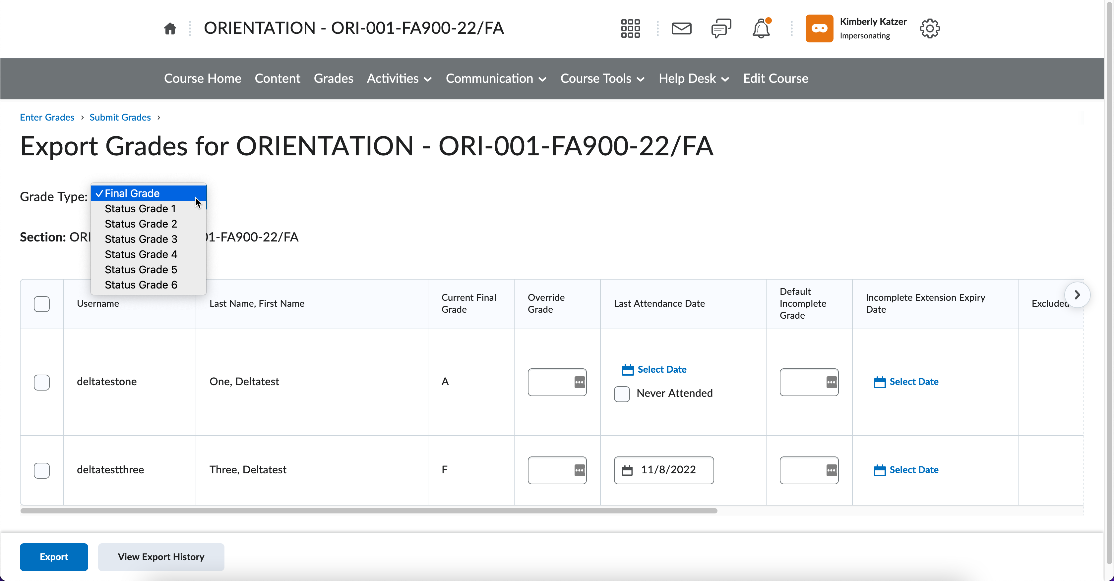
  - Merged Course – Select which section you want to submit using the dropdown next to Scope.
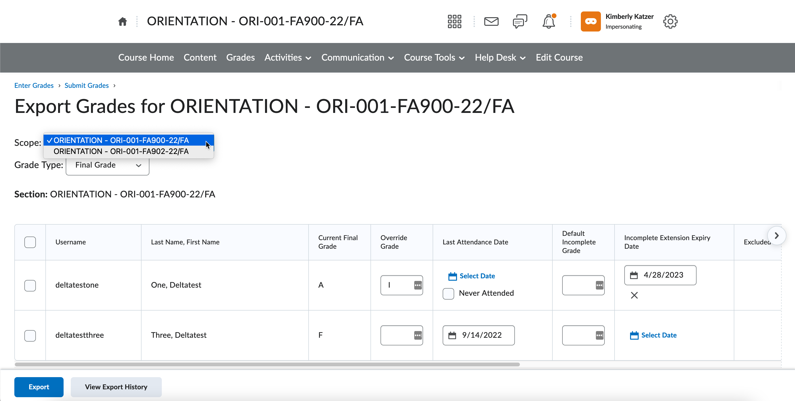
- Next, you will select the students you want to submit grades by clicking the check box on the left side next to their username. You can do one at a time, all your students or only some students.
  - You can add an Override Grade if deemed appropriate
    - You can enter an “I” (capitol i) in the Override grade to send in Incomplete to the system, you DO NOT need to enter a Default Incomplete Grade, these will automatically convert to an F if an incomplete is not finished within the time limited. It is required that you need to add a date under Last Attendance Date and you must select a date for the Incomplete Extension Expiry Date field (listed below). Last Date of Attendance is defined as, the date the student last had activity in the course. Just logging into D2L or the course is not enough to qualify as Last Date of Attendance. This date can be easily identified through Class Progress and running through the options. For instance, when did the student last submit an Assignment Dropbox, do a Discussion Board, or take a Quiz. All of these are date stamped and can be used to show Last Date of Attendance.
  - 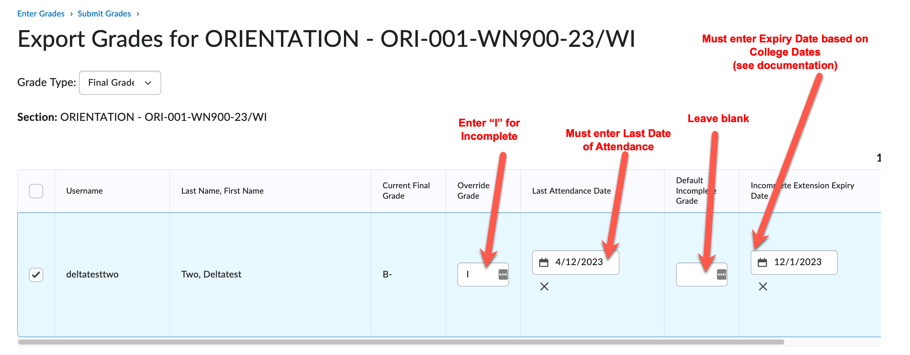
  - Incomplete Grade Deadlines:
    - For Fall courses, incomplete grades must be converted by April 1st of the following year.
    - For Winter and Spring/Summer courses, incomplete grade must be converted by December 1st
of current year.
    - Extensions due to extenuating circumstances must be approved by the Registrar.
  - If you do an Incomplete, you must still fill out an Incomplete Form for the student.
    - Refer to the the employee intranet documentation for faculty regarding Incomplete Students - https://intranet.example.edu/registration/grading.html Incomplete Student form - https://forms.example.edu/incompletegrade
    - When incomplete form is submitted the eLearning Office is notified and we will adjust the student’s access in D2L to Incomplete Student (Student2). This allows the student to access the course when it closes. There is NO NEED to leave the course open for in an Incomplete. Once an Incomplete has finished, the eLearning Office is notified again, and our office will change the status back.
  - “F” Grades Need Last Date of Attendance
    - All students receiving an F grades are required to enter a Last Date of Attendance.
    - This date MUST be entered in the date field and will default to “today’s” date. Click the box and enter the correct date based on Date of Last Activity in the course.
    - Last Date of Attendance is defined as, the date the student last had activity in the course. Just logging into D2L or the course is not enough to qualify as Last Date of Attendance. This date can be easily identified through Class Progress and running through the options. For instance, when did the student last submit an Assignment Dropbox, complete a Discussion Board, or take a Quiz. All of these are date stamped and can be used to show Last Date of Attendance.
  - Never Attended
    - If a student slid through the first of the semester drop period, you can select the Never Attended button for students who never attended class and do not have a grade listed.
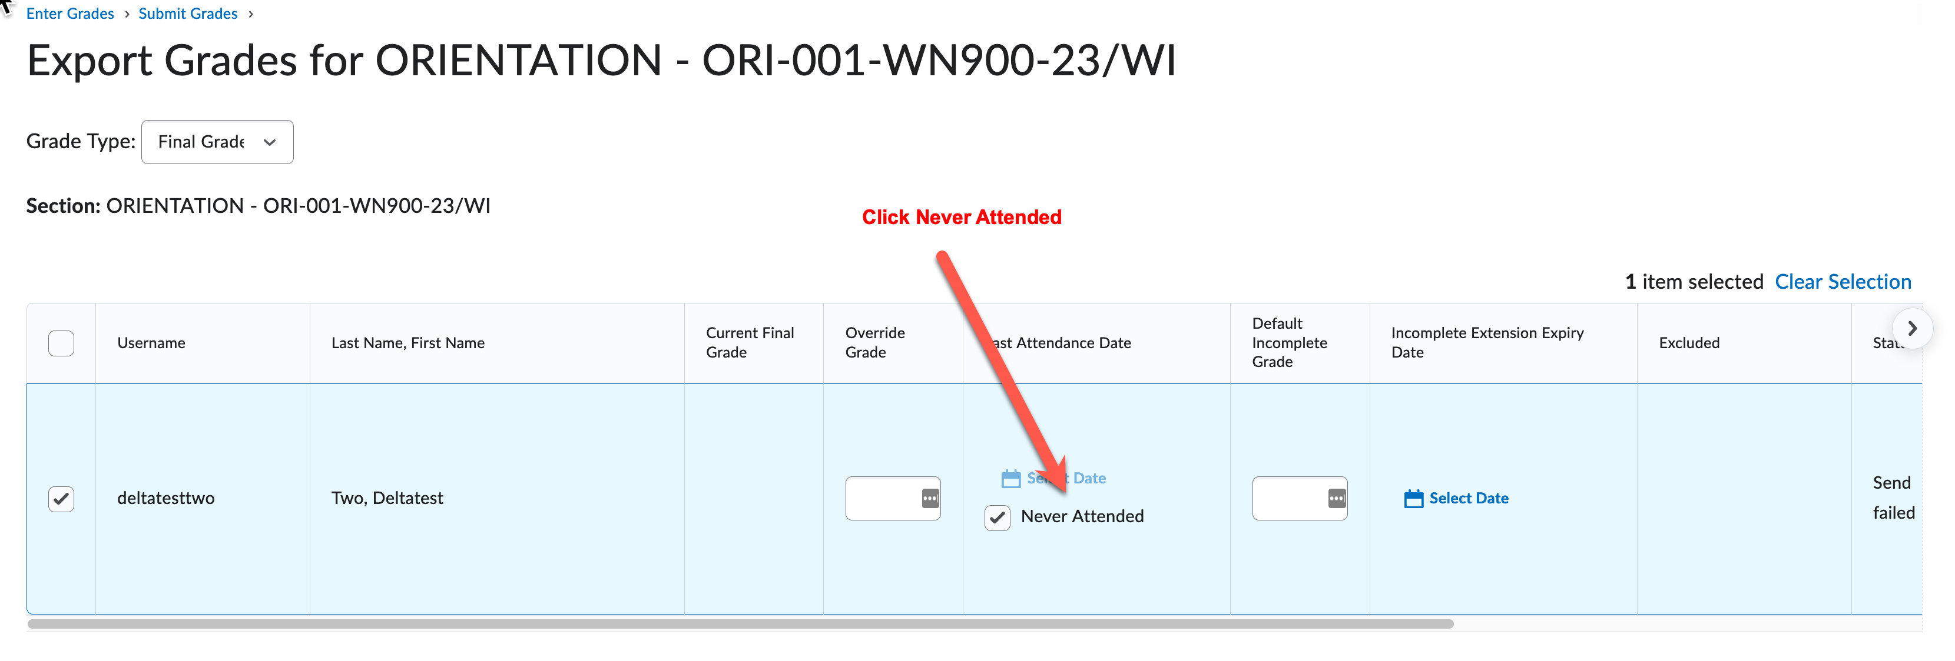
- Once you have selected the students you want to submit, click the blue Export at the bottom of the page.
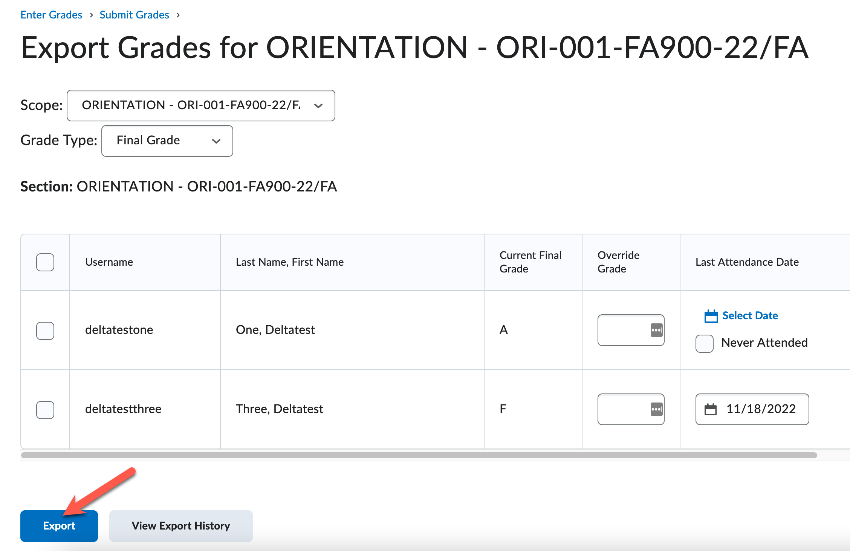
- On the Export page, here are a few items to look out for:
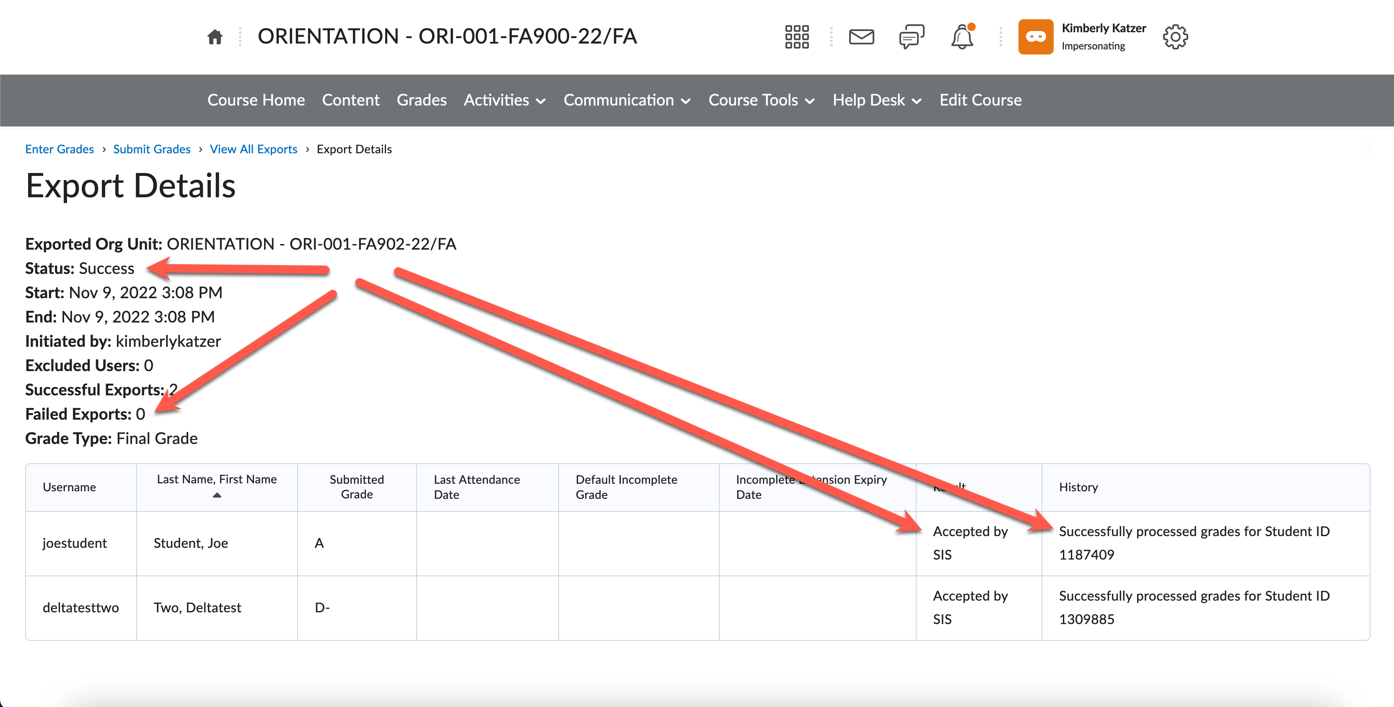
  - Status – this will change as the process works through the submission of grades
  - Failed Exports – this will let you know how many students failed to send the first round.
  - Accepted by SIS means that the grade was accepted by the Student Information System (SIS). If it has not, you will see ERROR.
  - History – submission information will stay in this box if you need to go back and review previous submission information. An error massage will report in this box if there was an error during submission.
- If you receive an error message, you can resubmit grades for just the students that did not go through on the first round. We have seen this in many tests that not all students go through the first push. If this happens, select the students that had an error and resubmit. This is a common error message when a student grade was not accepted. Resubmit the grade for this student.
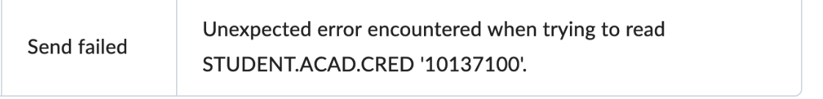
- Other Messages
  - Accepted – No other action required. You can double check grades submitted in Faculty Self-Serve
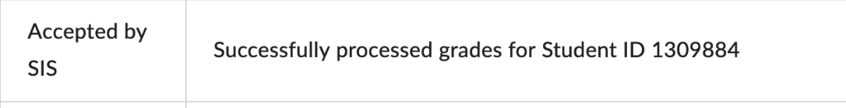

  - Excluded – you either forgot to check the box on the left side to select the student or on purpose to exclude that student in this submission.
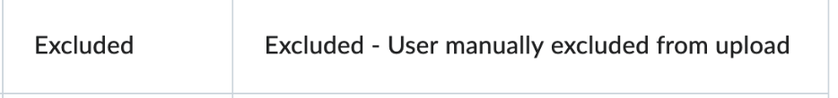
  - Send failed -Resubmit student
  - Send Failed – contact eLearning Office
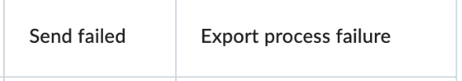
  - Send Failed – Incomplete grade requires a Last Date of Attendance date added.
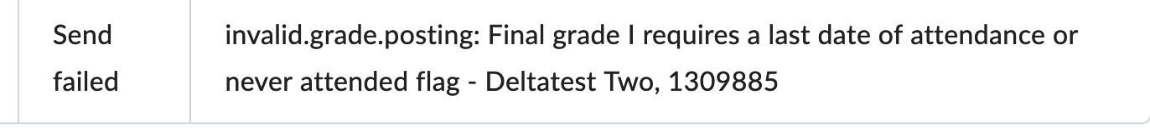
  - Send Failed – Incomplete grade requires an Expiry Date
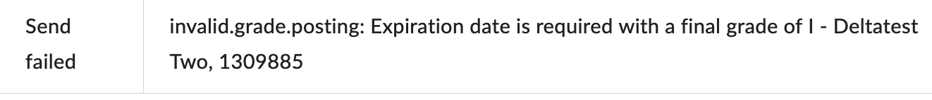
  - Last Date of Attendance – Resubmit with correct LDA date. D2L will default to “today’s” date and needs to be overridden with the correct date the student last had activity. The second error below is saying the student dropped the course but wasn’t removed from D2L and the date you entered after the student dropped from Colleague.
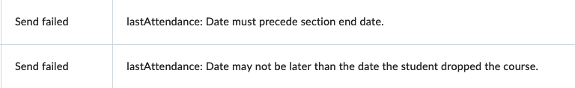
  - Invalid Grade Posting – You tried to submit a grade that has already been accepted and verified.
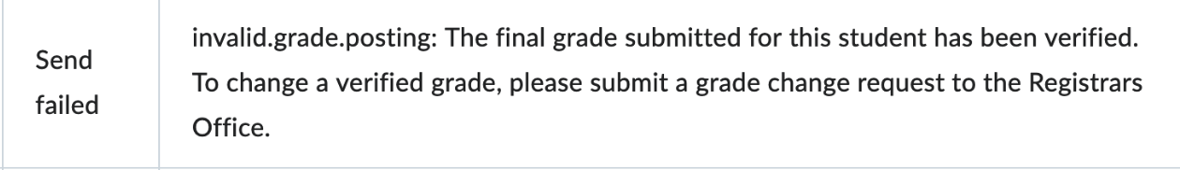
    - An instructor can submit and resubmit a new grade for a student anytime during the day.
    - After the grade has been verified overnight and a new grade is being submitted through D2L, you will receive an invalid grade posting error message and you will need to fill out a grade change request form. Refer to the the employee intranet page for more information - https://intranet.example.edu/registration/grading.html Grade Change form - https://forms.example.edu/gradechange

